***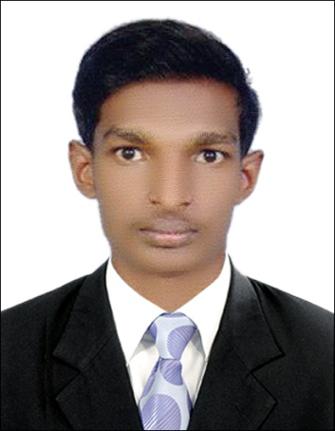* Curriculum Vitae**

**Dipin Raveendran**

Mobile: ***0553650129***

dipinr007@gmail.com

**Career Objective**

Seeking a challenging opportunity to demonstrate my skills and abilities and attain experience and knowledge in an organization offering scope for career growth and professional development. A challenging job profile providing experience and knowledge

**Personal Strengths**

* Excellent communication and interpersonal skills
* Ability to excel in a multi cultural environment.
* A team leader who can carry along and motivate the group.
* “Make it happen” positive attitude & approach to life.
* Target oriented, focused, with a good record of accomplishment.

**Academic Qualifications**

Basic Education : S.S.L.C (Board Examination Kerala)

(2007-2008)

Secondary Education : Vocational Higher Secondary Examination

(2009-2010)

Computer Literacy : MS Office (Word, Excel, Power Point),Tally 9

**UAE Driving License Details**

License No : 1824975

Issue Date : 15/09/2012

Expiry Date : 15/09/2022

Place of Issue : Dubai

Type of License : Light Vehicle

**Work Experience**

* Six month experience as an office Secretary cum sales representative in Karthika Automobile, Attingal Kallambalam.
* Three months experience as a sales assistant with Vettethuvila Hardware’s Venjarumoodu, Thiruvananthapuram, and Kerala.
* Three month experience as an office assistant with **Indian Space Research** **Organization** Thumba , Thiruvananthapuram, Kerala.
* Three years of experience as a purchase executive in **Lamprell Energy Ltd,** Sharjah UAE.
* One year experience as a Van sales with Baja Food Company L.L.C
* Still working with MH Enterprises L.L.C Dubai UAE.

(sales executive as a food product company)

**Personal Details**

Date of Birth : 27/11/1990

Age : 25 years

Nationality : Indian

Gender : Male

Marital Status : Single

Visa Status : Employment Visa

Languages known : English, Hindi, Malayalam, Tamil

**Passport Details**

Passport Number : H 4381799

Date of Issue : 09/09/ 2009

Date of Expiry : 08/09/2019

Place of Issue : Trivandrum

**Declarations**

I hereby declare that the information given above is true to my knowledge. If given an opportunity to serve in your organization. I’ll impart the duties to the at most satisfaction of the authority.

Place :

Date :

**Dipin Raveendran**